GLOBAL CONSTRUCTION MATERIAL MARKET TREND REPORT

Student’s Name

Course
Professor’s Name
University
City (State)
Date

Global Construction Material Market Trend Report
Cement

Source: Statista
The price of cement has been steadily rising for the last ten years. The price has witnessed an increase of over 30% per metric ton. With the constant increase in fuel prices, transport costs are bound to continue rising. The transport charges will then be transferred to customers through further increase in cement prices (Statista, 2021). However, in the period 2021-2023, prices may go down slightly due to Covid-19. Housing will have reduced priority compared to survival due to the loss of jobs and failure of businesses cause by thecovi-19 pandemic. The projections are that from 2023-2031, the price may move back up as people would have found alternative ways of survival and learned to live with the disease (Statista, 2021). When lives are back to normal, the demand for housing will go back up, warranting an increase in cement prices.

Timber
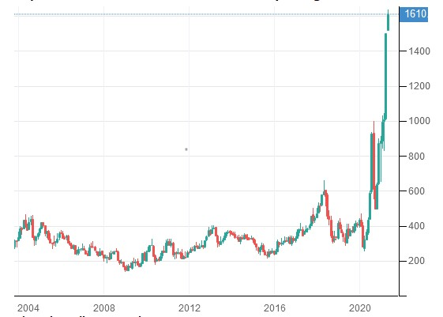
Source: Wolfstreet
The uses of timber in constructions are unlimited, from roofing, flooring, doors and cabinets. The price of timber has been rising steadily especially due to environmental concerns relating to conservation of trees to stop global warming. Demand for timber has also gone up. Additionally, the rural-urban shift witnessed worldwide has also led to increased demand for wood, leading to increased supply prices. The highest prices for timber were witnessed in 2019 on the onset of the covid-19 pandemic (Richter, 2021). This was mainly attributed to the closure of sawmills and transport restrictions around the world. When the sawmills reopened, the prices were still up as they sought to reclaim losses made during lockdowns and increased transport costs due to travel restrictions. The price of timber is projected to go higher by 2031 since environmental concerns are continually rising by the day.
Bricks
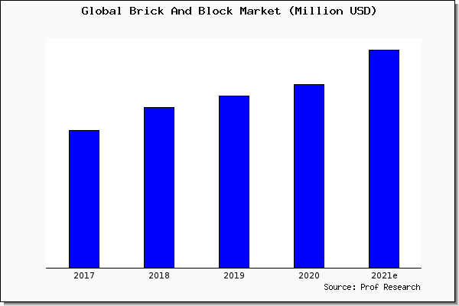
The price of earthen bricks have been rising compare to concrete bricks. The former is considered environmental friendly and cheaper. There are various types of bricks, with the price of each depending on the material used and the difficulty in production (Research, 2021). Interlocking blocks are cheaper than other bricks due to its requirement of less material and ease of production. Concrete bricks on the other hand depend on the price of concrete. If concrete prices are up, concrete price goes up. Earthen bricks are relatively difficult to produce, especially without machinery as in many African countries. As long as housing demand is still high, brick prices will continue rising regardless of the type (Research, 2021). Any decrease will be very slight followed by subsequent increase. Transport is also a factor that increases brick prices. Fuel prices rise by the day, affecting brick prices as they need transport from the production to the construction site.
Tiles
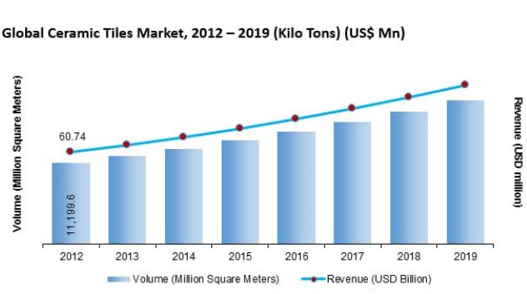
Source: Future Market insights
The price for tiles, especially roofing tiles are already up. However, this is attributed to the low market share of tiles over substitute products. It is projected that by 2030, the market share of tiles will have increased, leading to slight reduction in price. The lowest prices were witnessed in 2020 due to the severity of the covid-19 virus that caused industries to shut down and demand for tiles to fall. However, the price of tiles is also affected by other factors including production costs, global tariffs, transport costs and insurance. This means that the decrease may not be very evident if all the other costs are included. High demand for modern and environment friendly flooring and roofing may also affect the price upwards as more demand means more supply which can only be achieved through increased production. By 2030, the prices might be slightly higher due to the miscellaneous costs associated with production and transport of tiles (Kaitwade, 2021).
Steel
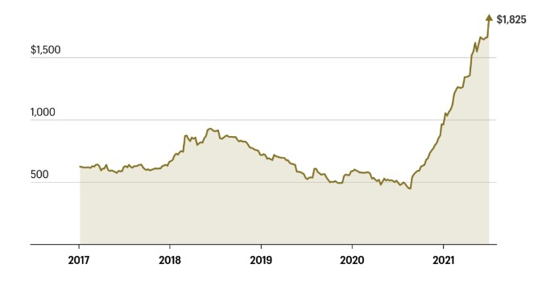
Source: Fortune
Steel uses in construction cannot be ignored. However, steel and wood have long complemented and supplemented each other. The global demand for steel has increased due to its durability and strength compared to wood. The upsurge in the demand for steel has in turn led to the increase in steel prices worldwide. Just like other construction materials, steel industry was also greatly affected by the covid-19 pandemic. Steel prices depend greatly on supply, if the supply grows to meet the current demand, prices will go down. However, continued increase in demand with less supply will lead to a projection of higher prices by 2030 (Lambert, 2021). This will also be affected by transport costs among other costs like government tariffs on steel importation.

Reference List
Kaitwade, N., 2021. New technologies and Eco-Friendly Construction to Boost Growth of Ceramic Tiles – FMI | Industry news and insights. [online] Fmiblog.com. Available at: https://www.fmiblog.com/new-technologies-and-eco-friendly-construction-to-boost-growth-of-ceramic-tiles/ [Accessed 2 October 2021].
Lambert, L., 2021. Steel prices are up 200%. When will the bubble pop?. [online] Fortune. Available at: <https://fortune.com/2021/07/08/steel-prices-2021-going-up-bubble/> [Accessed 2 October 2021].
Research, P., 2021. Brick And Block Market Size, Share, Trend and Forcarst to 2025 | Prof Research. [online]. Available at: <https://www.prof-research.com/Brick-And-Block-Market> [Accessed 2 October 2021].
Richter, W., 2021. Lumber: Scary-Crazy Inflation Now Gets Passed On. But These Price Spikes Cannot Last. [online] Wolf Street. Available at: <https://wolfstreet.com/2021/05/05/lumber-scary-crazy-inflation-now-gets-passed-on-but-these-wtf-price-spikes-cannot-last/> [Accessed 2 October 2021].
Statista, 2021. Cement price 2007-2020 | Statista. [online] Statista. Available at: <https://www.statista.com/statistics/219339/us-prices-of-cement/> [Accessed 2 October 2021].

